Project 3

**Date Assigned: 10/08/2015**

**Lab Report Due: Midnight 10/15/2015 on iLearn**

**Section 1: Who is the Winner?**

1. Create a folder **project3** on the desktop. Copy and paste html/css files you made in **project2**.
2. Our Tic Tac Toe game is great, but **NO ONE EVER WINS !!!** Let’s add a function to **check for a winner**. This is the hardest work, as there are lot’s of ways to win in Tic Tac Toe !
3. In **tictactoe.js,** add a definition of function “check_win()”

function check_win() {

}

Right now, the function is empty. We will add statements at later steps.

1. First we need to add a statement to find out who is the current player, “X” or “O” in check_win() by reading the contents of paragraph (id “currentplayer”) in tictactoe.html.

function check_win() {

// add a statement to find out who is the current player, “X” or “O” by reading the contents of paragraph (id “currentplayer”) in tictactoe.html, and save it in a variable called player

}

1. Then we are going to look for a win in **each row, each column, and the two diagonals**.

For example, one winning combination in our Tic-Tac-Toe game is:

**(0, 1, 2),**

where 0 represents the button with id “0”, and 1 represents the button with id “1”, and 2 represents the button with id “2”.

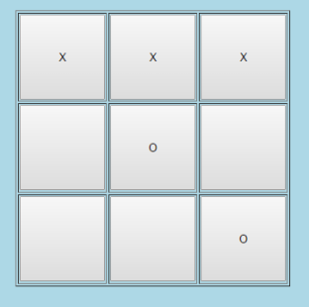

Write down all the winning combinations, and save your answers in **project3.txt/pdf/doc**.

1. In Tic-Tac-Toe game, whenever player “X”(or “O”) clicks on a button, we need to check if “X”(or “O”) wins, before we let the other player play. Thus we need to examine all possible winning combinations, to see whether “X” (or “O”) has achieved any of them. If “X” wins the game, his name “X” will be displayed in a congratulatory message. On the other hand, if there is no winner, game should continue ( let the other player play the game).

Here I show you an example to check if winning combination (0,1,2) has been achieved. You need to complete the function by checking other winning combinations.

function check_win() {

// add a statement to find out who is the current user, “X” or “O” by reading paragraph id “result” in tictactoe.html, and save it in a variable named “player”

// Check every possible wining combination

**if(document.getElementById(0).value == document.getElementById(1).value && document.getElementById(1).value == document.getElementById(2).value &&document.getElementById(1).value == player)**

**{**

**alert("You win! The winner is "+ player); // Check if (0,1,2) has been achieved**

**}**

// add statements to check the rest of winning combinations

// ...

**else{**

**changeplayer(); // nobody wins, change player**

**}**

}

1. In tictactoe.js, in function **click(idvalue), replace the statement “changeplayer()” by “check_win()”**.
2. Launch tictactoe.html in Chrome, and see if your function works.

**TURN-IN CHECKLIST:**

1. **Source Code (.html/.css/.js files) created in this assignment. Remember to include your name, the date, and the lab number in comments near the beginning of your code.**

**Create a folder and name it 'FirstName_LastName_Project3'. In the newly created folder copy and paste your source code (.html/.css/.js). Then compress the folder, and upload it to iLearn.**